The University of Azad Jammu and Kashmir, Muzaffarabad
Name | Danial Ayub Mughal
Roll Number | 2024_SE_20
Class | 4th Semester
Subject | Database Lab Report
Course Code | CS_2204
Submitted To | Engr. Awais Rathor


Lab Report

Department of Software Engineering

1. Introduction
The Car Rental Management System is a database-based system for managing customers, vehicles, rental transactions, and payments. The SQL implementation uses relational database concepts including primary keys, foreign keys, constraints, indexes, JOINs, a view, a trigger, a stored procedure, and optimization techniques.

2. Objectives
- Design and implement the CarGo_Rentals database.
- Organize data using normalized relational tables.
- Maintain relationships and data integrity using keys and constraints.
- Use JOIN queries and a reusable VIEW for reporting.
- Prevent double rental using a TRIGGER.
- Automate rental registration using a stored procedure.
- Improve query performance through indexes and selective queries.

3. Database Design
The database contains four main tables: Customer, Vehicle, Rental, and Payment. Customer stores customer-specific information; Vehicle stores vehicle information and status; Rental stores the business transaction linking a customer and vehicle; and Payment stores payment transactions separately.

3.1 Main Tables
Table | Important Fields | Purpose
Customer | CustomerID, Name, Phone, Email, CNIC | Stores customer information
Vehicle | VehicleID, Number, Model, Year, Rates, Status | Stores vehicle information
Rental | RentalID, CustomerID, VehicleID, Dates, Charge, Status | Stores rental transactions
Payment | PaymentID, RentalID, Amount, Method, Status | Stores payment transactions
Primary keys uniquely identify records, foreign keys maintain relationships, UNIQUE constraints prevent duplicate phone/email/CNIC/vehicle registration values, and CHECK constraints validate important values.
4. Relationships and Sample Data
- Customer → Rental: one customer can have multiple rental records.
- Vehicle → Rental: a vehicle can be rented multiple times over time, while active double rental is prevented.
- Rental → Payment: payment records are linked to a rental through RentalID.
The SQL file includes sample customers, vehicles, historical/active rentals, and payments. Vehicle status is updated to RENTED when active rentals exist.

3. Task 2 – Normalization

3.1 Given structure and dependencies
The company keeps each rental in one flat record. I added two more example rows (R002 and R003) so that the repeated data is easy to see.
Unnormalized form (0NF): Rental_Flat
RentalID | CustomerName | CustomerPhone | VehicleNumber | VehicleModel | DailyRate | RentalDate | ReturnDate | PaymentAmount
R001 | Ali Khan | 0300-1234567 | ABC-123 | Toyota Corolla | 5000 | 2026-09-01 | 2026-09-04 | 15000
R002 | Ali Khan | 0300-1234567 | BCD-234 | Toyota Corolla | 5000 | 2026-09-10 | 2026-09-13 | 5000, 10000
R003 | Sara Ahmed | 0321-7654321 | LEA-456 | Honda Civic | 6000 | 2026-08-10 | 2026-08-15 | 30000

Functional dependencies (FDs) found
FD | Dependency | Meaning
FD1 | RentalID → CustomerName, CustomerPhone, VehicleNumber, VehicleModel, DailyRate, RentalDate, ReturnDate | One rental gives one customer, one vehicle and its dates
FD2 | CustomerPhone → CustomerName | A phone number belongs to one customer
FD3 | VehicleNumber → VehicleModel | A number plate belongs to one model
FD4 | VehicleModel → DailyRate | The rate depends on the model (assumption A1)
FD5 | (RentalID, PaymentNo) → PaymentAmount | A rental can be paid in several parts (assumption A4)

3.2 First Normal Form (1NF)
Rule: each cell holds one single value, there are no repeating groups, and a primary key identifies each row.
Problem in 0NF | Fix applied
VehicleModel holds two facts in one cell (“Toyota Corolla” = make + model). We cannot search by make easily. | Split into VehicleMake and ModelName.
PaymentAmount can hold many values in one cell (“5000, 10000”). This is a repeating group. | One row per payment; add PaymentNo.
We need a key for the new one-row-per-payment layout. | Primary key = (RentalID, PaymentNo).
Rental_1NF (PK = RentalID + PaymentNo)
RentalID | PaymentNo | CustomerName | CustomerPhone | VehicleNumber | VehicleMake | ModelName | DailyRate | RentalDate | ReturnDate | PaymentAmount
R001 | 1 | Ali Khan | 0300-1234567 | ABC-123 | Toyota | Corolla | 5000 | 2026-09-01 | 2026-09-04 | 15000
R002 | 1 | Ali Khan | 0300-1234567 | BCD-234 | Toyota | Corolla | 5000 | 2026-09-10 | 2026-09-13 | 5000
R002 | 2 | Ali Khan | 0300-1234567 | BCD-234 | Toyota | Corolla | 5000 | 2026-09-10 | 2026-09-13 | 10000
R003 | 1 | Sara Ahmed | 0321-7654321 | LEA-456 | Honda | Civic | 6000 | 2026-08-10 | 2026-08-15 | 30000

3.3 Second Normal Form (2NF)
Rule: the table is in 1NF, and no normal column depends on only a part of the key (no partial dependency).
Partial dependency (part of key → attribute) | Effect | Decomposition
RentalID → CustomerName, CustomerPhone, VehicleNumber, VehicleMake, ModelName, DailyRate, RentalDate, ReturnDate | These 8 columns depend only on RentalID, not on PaymentNo, so they repeat on each payment row. | Move them to Rental_2NF (PK RentalID)
(RentalID, PaymentNo) → PaymentAmount | Depends on the whole key, so it stays. | Payment_2NF (PK RentalID + PaymentNo, FK RentalID)
Rental_2NF (PK = RentalID)

RentalID | CustomerName | CustomerPhone | VehicleNumber | VehicleMake | ModelName | DailyRate | RentalDate | ReturnDate
R001 | Ali Khan | 0300-1234567 | ABC-123 | Toyota | Corolla | 5000 | 2026-09-01 | 2026-09-04
R002 | Ali Khan | 0300-1234567 | BCD-234 | Toyota | Corolla | 5000 | 2026-09-10 | 2026-09-13
R003 | Sara Ahmed | 0321-7654321 | LEA-456 | Honda | Civic | 6000 | 2026-08-10 | 2026-08-15
Payment_2NF (PK = RentalID + PaymentNo, FK = RentalID)

RentalID | PaymentNo | PaymentAmount
R001 | 1 | 15000
R002 | 1 | 5000
R002 | 2 | 10000
R003 | 1 | 30000

3.4 Third Normal Form (3NF)
Rule: the table is in 2NF, and no normal column depends on another normal column (no transitive dependency).
Transitive dependency | Why it is a problem | Decomposition
RentalID → CustomerPhone → CustomerName (FD2) | Customer data repeats in every rental of that customer. | Customer (new key CustomerID; Phone is also unique)
RentalID → VehicleNumber → VehicleMake, ModelName (FD3) | Vehicle/model data repeats for every rental of the vehicle. | Vehicle (PK VehicleNumber, FK ModelID)
VehicleNumber → Model → DailyRate (FD3 + FD4) | The rate repeats for every car of the same model. | VehicleModel (PK ModelID: make, model, rate)
Final 3NF relations
Relation | Attributes | Sample rows
Customer | CustomerID (PK), CustomerName, CustomerPhone | 1 | Ali Khan | 0300-1234567  2 | Sara Ahmed | 0321-7654321
VehicleModel | ModelID (PK), VehicleMake, ModelName, DailyRate | 1 | Toyota | Corolla | 5000  2 | Honda | Civic | 6000
Vehicle | VehicleNumber (PK), ModelID (FK) | ABC-123 | 1  BCD-234 | 1  LEA-456 | 2
Rental | RentalID (PK), CustomerID (FK), VehicleNumber (FK), RentalDate, ReturnDate | R001 | 1 | ABC-123 | 2026-09-01 | 2026-09-04  R002 | 1 | BCD-234 | 2026-09-10 | 2026-09-13  R003 | 2 | LEA-456 | 2026-08-10 | 2026-08-15
Payment | RentalID (PK, FK), PaymentNo (PK), PaymentAmount | R001 | 1 | 15000  R002 | 1 | 5000  R002 | 2 | 10000  R003 | 1 | 30000

How the 3NF design maps to the implemented database

3NF relation | Implemented table | Additions made for the real system
Customer | Customer | Email, CNIC, LicenseNo, City, RegisteredOn
VehicleModel | VehicleModel | Category, Seats
Vehicle | Vehicle | VehicleID number key (plate kept UNIQUE), Color, ManufactureYear, Status
Rental | Rental | DueDate, DailyRateApplied, TotalCharge, RentalStatus; ReturnDate moved out
Rental.ReturnDate | VehicleReturn | Own table (1 : 1) with LateFee, VehicleCondition, Remarks. This is a design choice, not a 3NF need
Payment | Payment | PaymentID number key, PaymentDate, PaymentMethod

6. JOIN Queries and Reporting
The project implements four required JOIN queries. An INNER JOIN displays customer, vehicle, rental, and return information. LEFT JOIN queries include customers with no rentals and vehicles that are not currently rented. Another query uses COUNT() and GROUP BY to calculate total rentals for each customer.
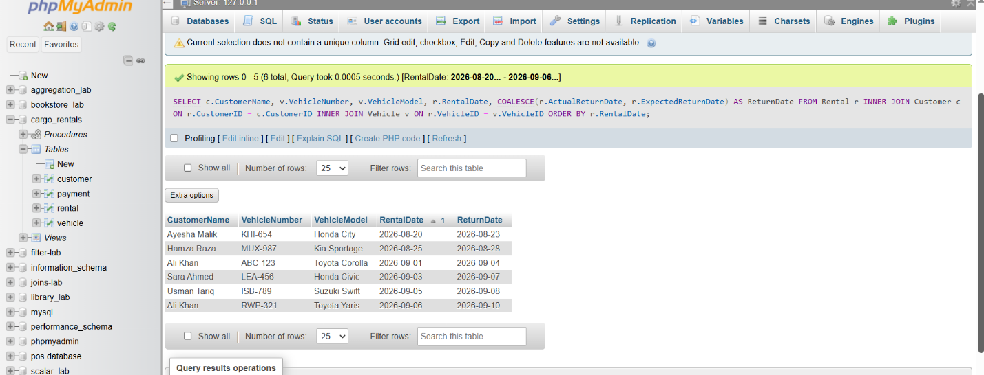

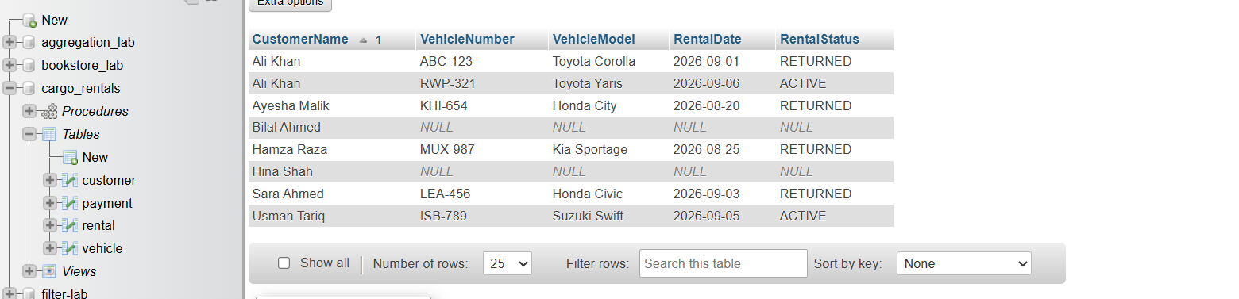

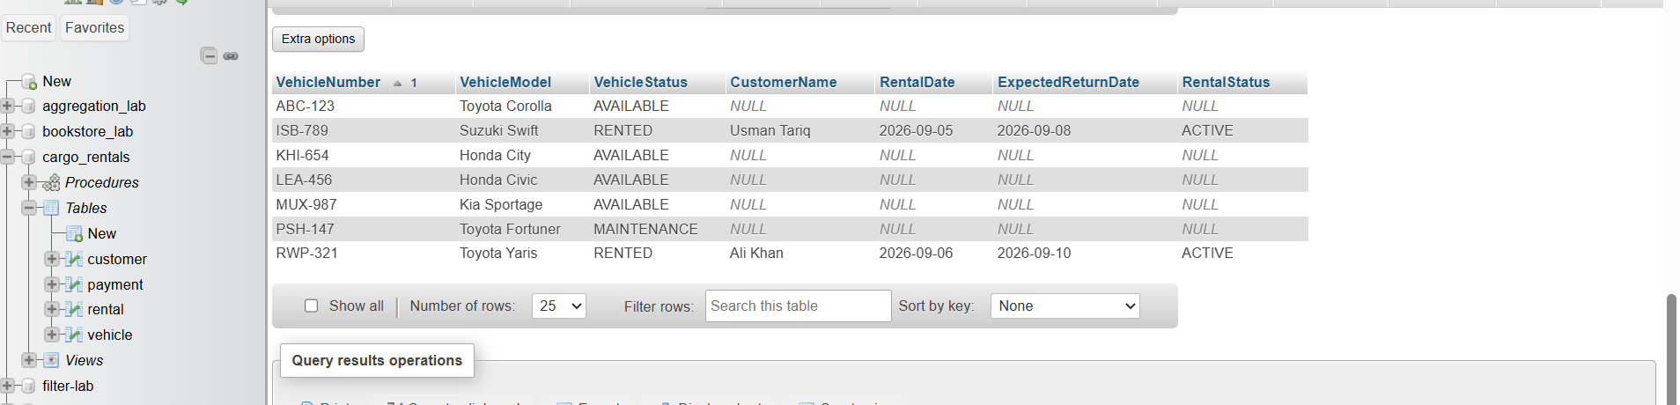

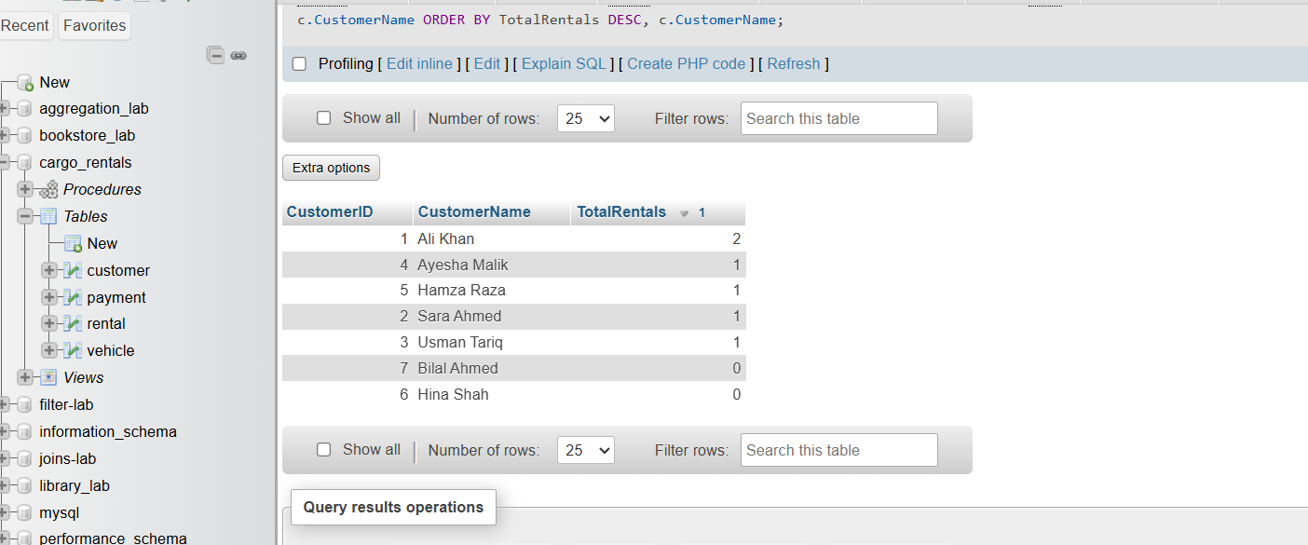

6.1 Rental Report View
The view vw_RentalReport combines Customer, Vehicle, Rental, and Payment data. It calculates AmountPaid using SUM() and the remaining Balance using RentalCharge minus the amount paid. This provides a reusable management report.

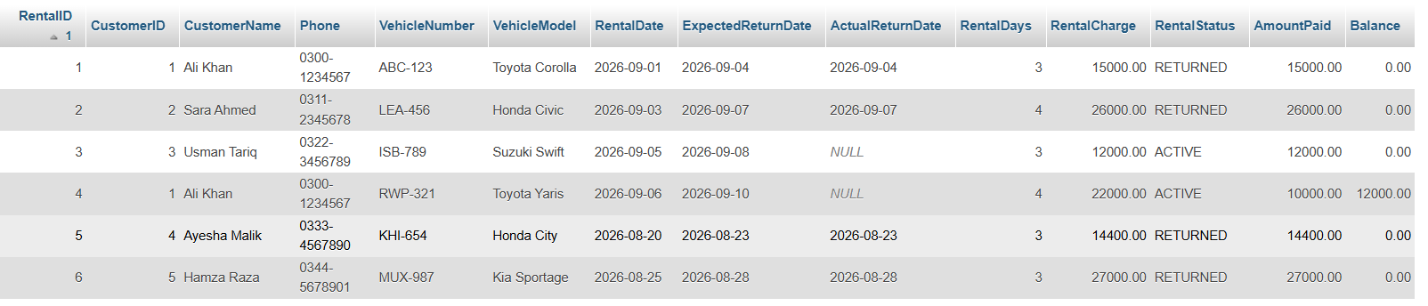

7. Trigger
The trigger trg_PreventDoubleRental runs BEFORE INSERT on Rental. It checks whether the selected vehicle already has an ACTIVE rental. If it does, the trigger raises an error and prevents the new rental. This enforces the business rule that a vehicle cannot be assigned to two active rentals.
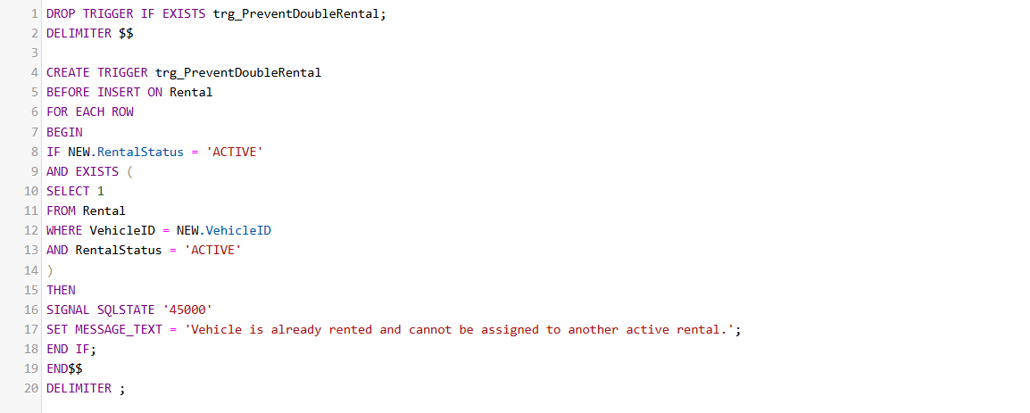

8. Stored Procedure
RegisterRental automates the rental registration process. It validates the customer and vehicle, checks the dates, verifies vehicle availability, reads the daily rate, calculates rental days and total charge, inserts the rental, changes the vehicle status to RENTED, and returns the new rental details.
The procedure treats a same-day rental as one rental day.

9. Return Operation
The SQL file provides an example return operation using a transaction. The rental is changed to RETURNED with an actual return date, the related vehicle is changed to AVAILABLE, and COMMIT completes the operation. This supports consistency between rental and vehicle status.

10. Indexing and Optimization
Indexes are created on Rental(CustomerID), Rental(VehicleID, RentalStatus), rental dates, and Payment(RentalID). These indexes support common lookup, JOIN, and filtering operations.
For active-rental reporting, the improved query filters with RentalStatus = 'ACTIVE' instead of retrieving unnecessary rental records. EXPLAIN can be used to inspect the query execution plan.

11. Management Reports
- Customer rental history: shows customer, vehicle, dates, charges, and rental status.
- Currently rented vehicles: shows vehicle, customer, rental dates, and charge for active rentals.
- Vehicle rental activity: calculates total rentals, total rental days, and total revenue for each vehicle.
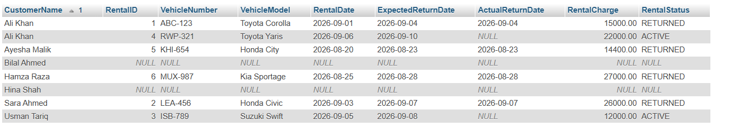

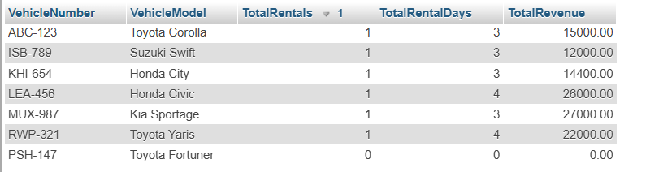

12. Key Concepts Used
Concept | Implementation
Primary/Foreign Keys | CustomerID, VehicleID, RentalID, PaymentID and relationships
Constraints | UNIQUE, CHECK, NOT NULL, DEFAULT
JOINs | INNER JOIN and LEFT JOIN
Aggregation | COUNT(), SUM(), GROUP BY
View | vw_RentalReport
Trigger | trg_PreventDoubleRental
Procedure | RegisterRental
Indexes | Rental and Payment indexes
Transaction | Vehicle return operation
Optimization | Selective query and EXPLAIN

13. Advantages
- Reduces data redundancy through normalization.
- Improves integrity through keys and constraints.
- Prevents double rental through the trigger.
- Automates rental calculations through the procedure.
- Provides reusable reports through the view and JOIN queries.
- Supports better query performance through indexes.

14. Conclusion
The Car Rental Management System demonstrates the practical application of relational database concepts in a real-world rental scenario. The normalized design separates customers, vehicles, rentals, and payments while maintaining relationships through keys. JOINs and the rental-report view provide useful reporting, the trigger protects against double rental, and the stored procedure automates rental registration. Indexing and query optimization further support efficient database operation.

